Basic Course in Medical Education (BCME)

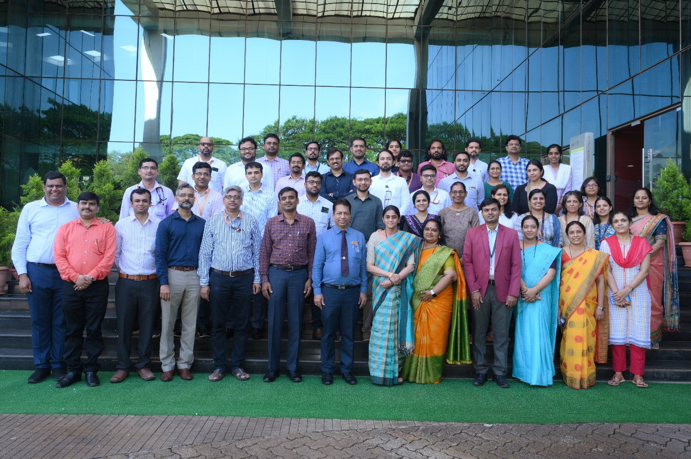
BCME workshop – 16th to 18th September 2024

Nodal Centre In Medical Education Technologies: Government Medical College, Kozhikode

Dates of Workshop : 16th to 18th September 2024
Dean/Director/Principal’s Name | Dr.Padmaraj Hegde
Convener/Head of Medical Education Unit Name | Dr. Kirtana R Nayak
Name of MCI Observer | Dr.Vrinda J Bhat

Sl. No. | Name of Participant | Designation and Department
 | Dr. Arjun Asok | Assistant Professor, Department of Biochemistry
 | Dr. Vasudha Devi | Associate Professor, Department of Pharmacology
 | Dr. Yash Alok | Assistant Professor, Department of Community Medicine
 | Dr. Akhila D | Assistant Professor, Department of Community Medicine
 | Dr. Aparna Jayakala | Assistant Professor, Department of Forensic Medicine
 | Dr. Mahesh Nayak | Assistant Professor, Department of Anaesthesiology
 | Dr. Shreya Das Adhikari | Assistant Professor, Department of Anaesthesiology
 | Dr. Pavan Madhukar Bhat | Assistant Professor, Department of General Surgery
 | Dr. Prasad S S | Professor, Department of General Surgery
 | Dr. Deepika U Kamath S | Assistant Professor, Department of OTO Rhino Laryngology
 | Dr. Sivapriya Vaidyanathan | Assistant Professor, Department of Psychiatry
 | Dr. Lalani Kanhai Rajendra | Assistant Professor, Department of Cardiology
 | Dr. Akkatai S Teli | Associate Professor, Department of Cardiology
 | Dr. Roshan Joseph Fernandes | Assistant Professor, Department of Critical Care
 | Dr. Rajendra Prasad Anne | Assistant Professor, Department of Neonatology
 | Dr. Anuja Dwarkadas Damani | Associate Professor, Department of Palliative Medicine & Supportive Care
 | Dr. Harshavardhan Kushal Shetty | Assistant Professor, Department of Plastic Surgery
 | Dr. Siddalingeshwara Chandragouda Doddamani | Assistant Professor, Department of Urology
 | Dr. Susanth S | Associate Professor, Department of Neuro Surgery
 | Dr. Swathi P M | Assistant Professor, Department of Pediatric Hematology and Oncology
 | Dr. Karthik S Udupa | Professor, Department of Medical Oncology
 | Dr. Kinjal Shankar Majumdar | Assistant Professor, Department of Head and Neck Surgery
 | Dr. Avivar Awasthi | Assistant Professor, Department of Endocrinology
 | Dr. Ankita | Assistant Professor, Department of Radiotherapy
 | Dr Jeffrey Pradeep Raj | Associate Professor, Division of Clinical Pharmacology, Department of Pharmacology
 | Dr. Meera R | Assistant Professor, Department of Neurology
 | Dr. Aditya V.A. Gunturi | Assistant Professor, Department of Radiodiagnosis and Imaging
 | Dr. Praveen C Samuel | Assistant Professor, Department of Paediatrics
 | Dr. Vivekananda Bhat | Assistant Professor, Department of Medical Genetics
 | Dr. Sindhu Sujeeth Hegde | Assistant Professor, Department of General Medicine

