Basic Course in Medical Education (BCME)

BCME workshop – 2nd to 4th January 2025
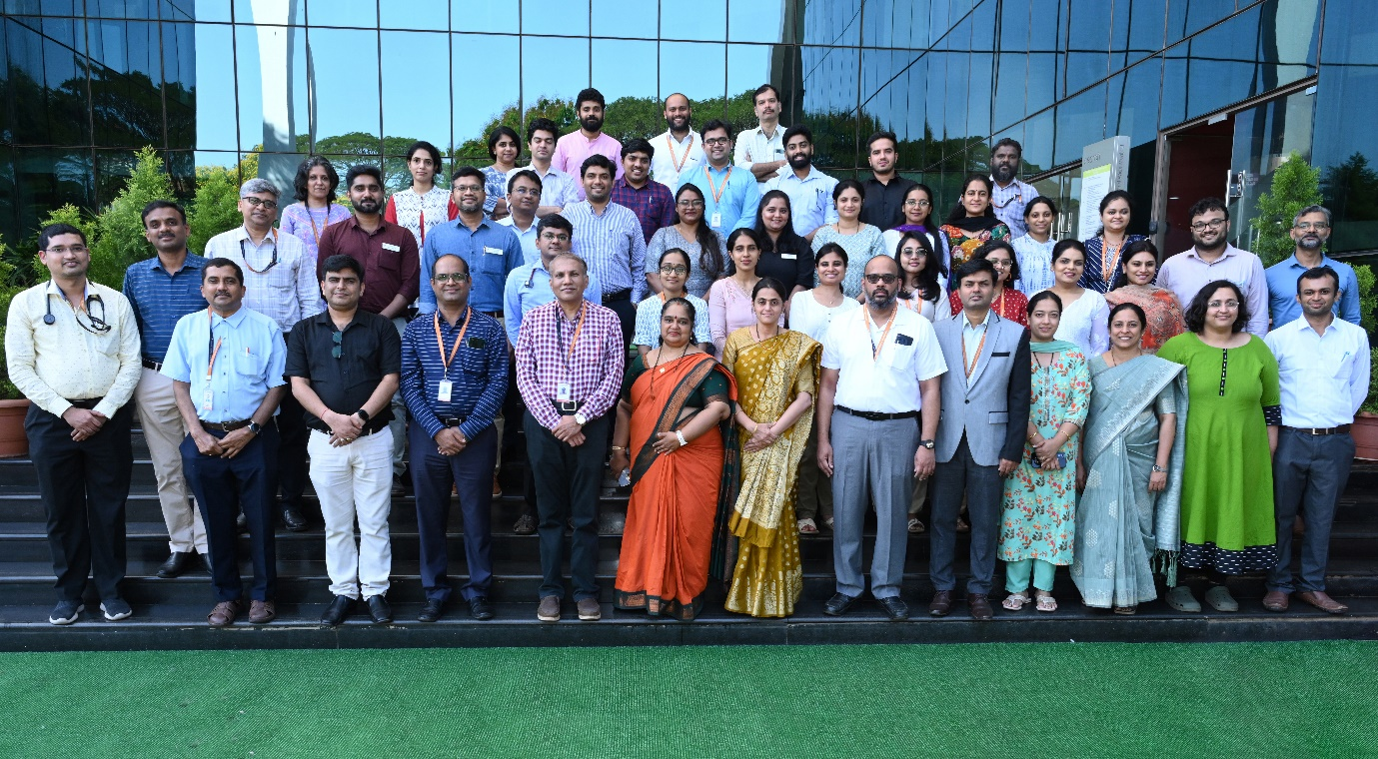
Nodal Centre In Medical Education Technologies: Government Medical College, Kozhikode

Dates of Workshop : 2nd to 4th January 2025
Dean/Director/Principal’s Name | Dr.Padmaraj Hegde
Convener/Head of Medical Education Unit Name | Dr. Kirtana R Nayak
Name of MCI Observer | Dr.Vrinda J Bhat

Sl. No. | Name of Participant | Designation and Department
 | Dr. Mukund A Prabhu | Associate Professor, Department of Cardiology
 | Dr. Monika P Jawanjal | Assistant Professor, Department of Cardiology
 | Dr. Sumanth R | Assistant Professor, Department of Cardiothoracic Surgery
 | Dr. Vinayak N Anchan | Assistant Professor, Department of Dermatology
 | Dr. Swathi C Prabhu | Assistant Professor, Department of Pathology
 | Dr. Sreenath N | Assistant Professor, Department of Physiology
 | Dr. Abhiram P.N. | Assistant Professor, Department of Psychiatry
 | Dr. Amrtavarshini R | Assistant Professor, Department of Psychiatry
 | Dr. Vrinda Mariya Elenjickal | Assistant Professor, Department of Pulmonary Medicine
 | Dr. Harshith Kramadhari | Assistant Professor, Department of Radiodiagnosis and Imaging
 | Dr.Raghavendra | Assistant Professor, Department of Surgical Gastroenterology
 | Dr. Afraz Jahan | Assistant Professor, Department of Community Medicine
 | Dr. Manasa U | Assistant Professor, Department of General Surgery
 | Dr. Deepa R | Assistant Professor, Department of Obstetrics and Gynaecology
 | Dr. Mahidhar Jeedigunta | Assistant Professor, Department of Cardiology
 | Dr. Umesh Thonse | Assistant Professor, Department of Psychiatry
 | Dr. Nagarathna Vilas Nayak | Assistant Professor, Department of Cardiology
 | Dr. Sachin Kumar | Assistant Professor, Department of Orthopaedics
 | Dr. Jegan Mohan S | Assistant Professor, Department of General Surgery
 | Dr. Arunangshu Ghoshal | Assistant Professor, Department of Palliative Medicine and Supportive Care
 | Dr. Jayashree N.P. | Assistant Professor, Department of Radiotherapy
 | Dr. Emine A Rahiman | Assistant Professor, Pediatric Hematology-Oncology
 | Dr. Aishwarya T R | Assistant Professor, Department of Hospital Administration
 | Dr. Divya D Pai | Assistant Professor, Department of Medicine
 | Dr. Shreya Gupta | Assistant Professor, Department of Pharmacology
 | Dr. Sharath P.S. | Assistant Professor, Department of Neurology
 | Dr. Akshatha R | Assistant Professor, Department of Infectious Diseases
 | Dr. Suvajit Podder | Assistant Professor, Department of Anaesthesiology
 | Dr. Sahana Shetty | Professor, Department of Endocrinology
 | Dr. Megha Murali | Assistant Professor, Department of Pathology

