Basic Course in Medical Education (BCME)

BCME workshop – 20th to 22nd March 2025
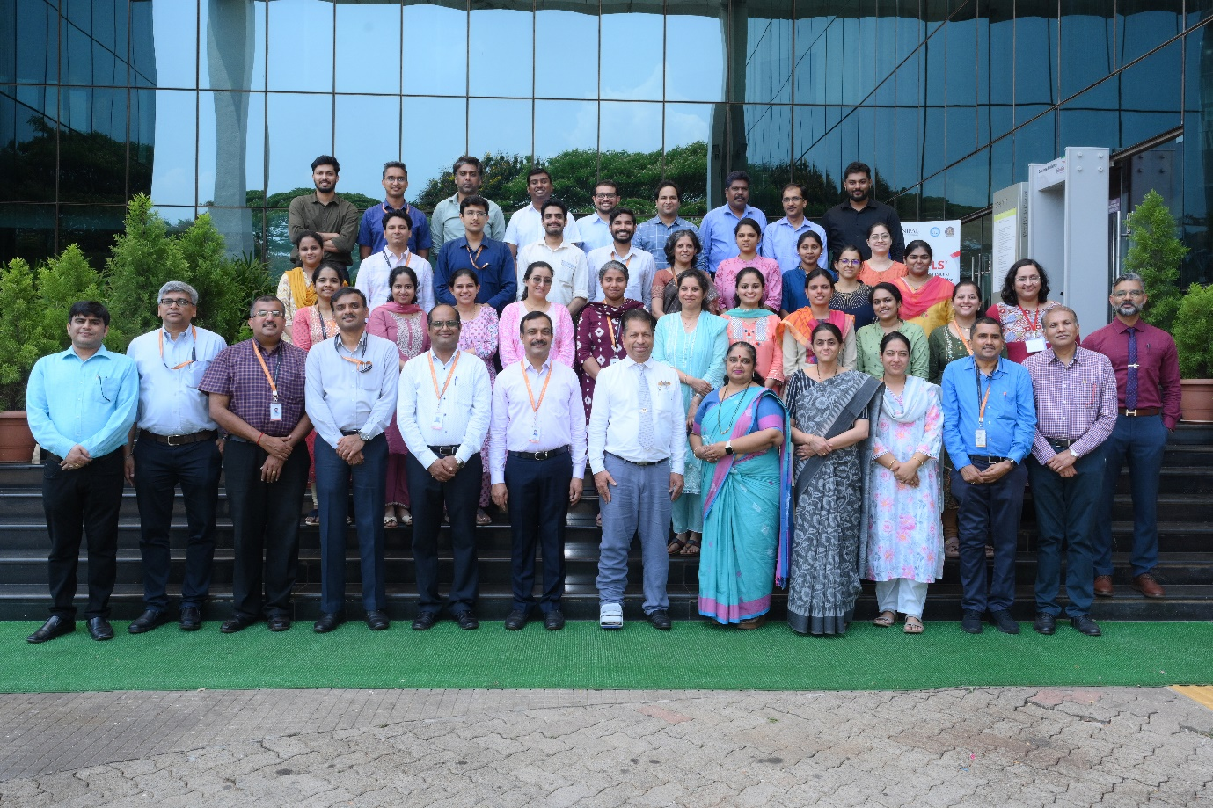
Nodal Centre In Medical Education Technologies: Government Medical College, Kozhikode

Dates of Workshop : 20th to 22nd March 2025
Dean/Director/Principal’s Name | Dr.Padmaraj Hegde
Convener/Head of Medical Education Unit Name | Dr. Kirtana R Nayak
Name of MCI Observer | Dr.Vrinda J Bhat

Sl. No. | Name of Participant | Designation and Department
 | Dr. Aparna Satish | Assistant Professor, Department of Anaesthesiology
 | Dr. Arjun Balakrishnan | Assistant Professor, Department of Anaesthesiology
 | Dr. Nandini Prashanth Bhat | Assistant Professor, Department of Anatomy
 | Dr. R Huban Thomas | Assistant Professor, Department of Anatomy
 | Dr. Srilatha K | Assistant Professor, Department of Biochemistry
 | Dr. Rakshitha R Shenoy | Assistant Professor, Department of Community Medicine
 | Dr. Lakshmy Sajeevan | Assistant Professor, Department of Forensic Medicine
 | Dr. Deep Madkaiker | Assistant Professor, Department of Immuno Haematology and Blood Transfusion
 | Dr. Mounika Cherukuri | Assistant Professor, Department of General Medicine
 | Dr. Suraj Rao H | Assistant Professor, Department of General Medicine
 | Dr. Poonam Ashok Kamath | Assistant Professor, Department of General Medicine
 | Dr. Nithin Raj S. D. | Assistant Professor, Department of Neuro Surgery
 | Dr. Prathiksha K | Assistant Professor, Department of Obstetrics and Gynaecology
 | Dr. Argyia Desouza | Assistant Professor, Department of Obstetrics and Gynaecology
 | Dr. Rakshitha Samanth | Assistant Professor, Department of OTO Rhino Laryngology
 | Dr. Sneha V | Assistant Professor, Department of OTO Rhino Laryngology
 | Dr. Tanvi Rao | Assistant Professor, Department of Plastic Surgery
 | Dr. Ashok Jammigumpula | Assistant Professor, Department of Psychiatry
 | Dr. Divya Balan | Assistant Professor, Department of Pulmonary Medicine
 | Dr. Mithun Shekar | Assistant Professor, Department of Radiodiagnosis and Imaging
 | Dr. Sharadhini K | Assistant Professor, Department of Radiodiagnosis and Imaging
 | Dr. Meera K | Assistant Professor, Department of General Surgery
 | Dr. Rajani Upadhyaya | Assistant Professor, Department of Obstetrics and Gynaecology
 | Dr. Sanketh Bhat S | Assistant Professor, Department of General Surgery
 | Dr. Roshen M Samuel | Assistant Professor, Department of General Surgery
 | Dr. Bishak S Reddy | Assistant Professor, Department of Orthopaedics
 | Dr. Prashant Bhatele | Assistant Professor, Department of Neurology
 | Dr. Sanjay Rao Kordcal | Assistant Professor, Department of Neurology

