Medical Education Department Unit
Sl.No | Name | Designation | Training Received
1 | Dr. Veena Nayak | Head, Department of Medical Education & Associate Professor,  Department of Pharmacology | Revised Basic MET –  October 2016  AETCOM - October 2016  FAIMER- April 2018  CISP – May 2019  ACME - 2020 | 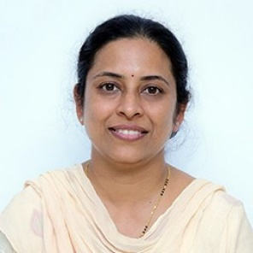
2 | Dr. Krishnananda Prabhu | Professor,  Department of Biochemistry | FAIMER -2014  ACME - October 2017  Revised Basic MET - March 2018  AETCOM – March 2018  CISP – July 2020 | 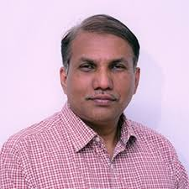
3 | Dr. Ravindra Maradi | Professor and Head  Department of Biochemistry | Revised Basic MET - June 2016  AETCOM - June 2016  ACME- September 2020  CISP II – August 2020 | 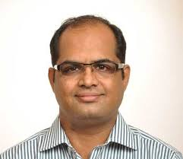
4 | Dr. Kirthinath Ballala A B | Associate Professor,  Department of Community Medicine | Revised Basic MET- - December 2015  AETCOM – October 2016  ACME - May 2018  CISP III – January 2025 | 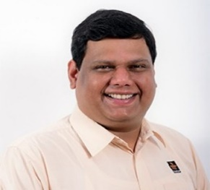
5 | Dr. Arvind Kumar Pandey | Associate Professor,  Department of Anatomy | Revised Basic MET –  June 2016  AETCOM -June 2016  FAIMER -2017  ACME - September 2018  CISP II – July 2020 | 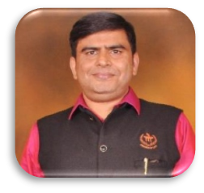
6 | Dr. Prakash P Y | Associate Professor,  Department of Microbiology | FAIMER- 2017  Revised Basic MET –  October 2017  AETCOM- October 2017  ACME - October 2019  CISP – August 2020 | 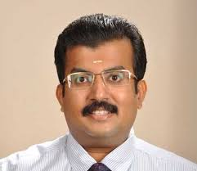
7 | Dr. Vikram Palimar | Professor,  Department of Forensic Medicine | Revised Basic MET –  June 2018  AETCOM - June 2018  ACME – September 2018B  CISP – July 2020 | 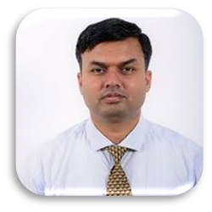
8 |  | Professor,  Department of Psychiatry | FAIMER- 2019  CISP I – June 2019  Revised Basic MET – July 2021  ACME - 2023 | 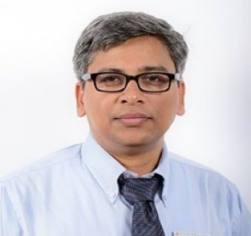
  Dr. Samir Kumar Praharaj
9 |  | Professor  Department of Biochemistry | ACME - September, 2018  CISP I – June 2019  Revised Basic MET – October 2022 | 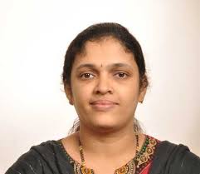
  Dr.Varashree B S
10 | Dr.Vijetha Shenoy Belle | Associate Professor  Department of Biochemistry | CISP II - 2020  BCME – August 2023  FAIMER -2023(B) | 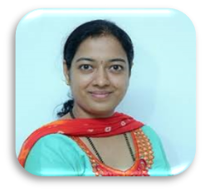
11 | Dr.M Mukhyaprana Prabhu | Professor and Head  Department of Medicine | FAIMER - May 2017  CISP I – June 2019  Revised Basic MET – October 2022 | 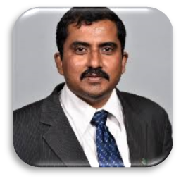
12 | Dr.Seemitr Verma | Associate Professor,  Department of Pathology | Revised Basic MET- July 2021  BCME -November 2023 | 
13 | Dr.Vimal Krishnan S | Professor and Head  Department of Emergency Medicine | FAIMER – 2020B  Revised Basic MET – July 2021  AETCOM – July 2021  ACME – 2023B  CISP III - 2024 | 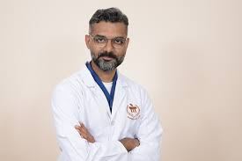
14 | Dr.Sushma Prabhath | Associate Professor,  Department of Anatomy | FAMER - 2020  CISP II- July 2020  Revised Basic MET – December 2021  AETCOM – December – 2021  ACME-2023B | 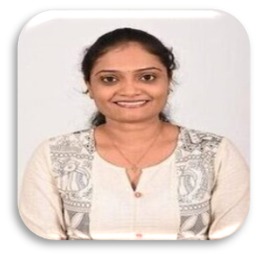
15 | Dr.Sharada M | Associate Professor  Department of Medical Oncology | Revised Basic MET- July 2021 | 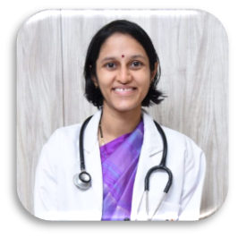
16 | Dr. Prithvishree Ravindra | Additional Professor  Department of Emergency Medicine | Revised Basic MET – July 2018  BCME – July 2023 | 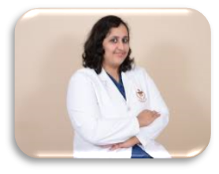
17 | Dr.Sunil R | Associate Professor  Department of Critical Care | Revised Basic MET – December 2021  AETCOM – December 2021  CISP III – 2024  ACME 2024B | 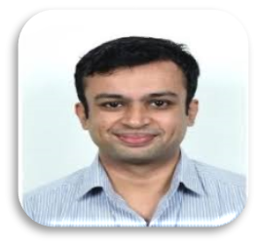
18 | Dr.Madhava Pai Kanhahgad | Assistant Professor,  Department of Orthopaedics | Revised Basic MET – July 2021  CISP III – January 2025 | 
19 | Dr.Shivdas Rajaram Naik | Assistant Professor,  Department of Infectious Diseases | BCME – August 2023  CISP III – July 2024 | 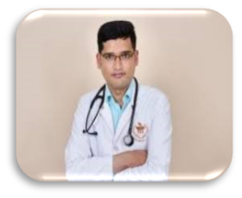
20 | Dr. Kirtana R Nayak | Professor & Head, Department of Physiology | Revised Basic MET - December 2015  AETCOM -October 2016  ACME - May 2018  CISP I – March 2019  FAIMER - 2021 | 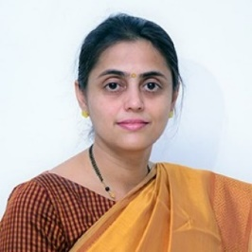
21 | Dr.Shashidhar V | Professor & Head  Department of Microbiology | ACME – 2019  CISP I – June 2019  Revised Basic MET- October 2022 | 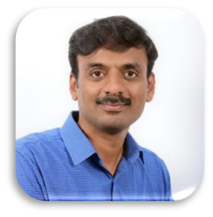
22 | Dr. Leslie Edward Lewis | Professor  Department of Paediatrics | Revised Basic MET – September 2015  AETCOM - October 2015  ACME - September 2018  CISP – May 2019 | 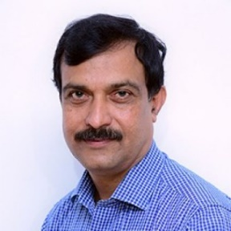
23 | Dr Suma T Udupa | Associate Professor  Department of Psychiatry | Revised Basic MET – March 2018  AETCOM – March 2018  BCME – August 2023  ACME 2024B | 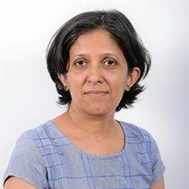
24 | Dr Shyamasunder Bhat N | Professor,  Department of Orthopaedics | Revised Basic MET – October 2016  AETCOM – October 2016  CISP I- June 2019  FAIMER - 2021  BCME – August 2023 | 
25 | Dr.Pavan Madhukar Bhat | Assistant Professor,  Department of General Surgery | Revised Basic MET – Sept – 2024  CISP III - Jan 2025 | 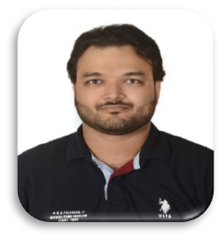

3. Activities conducted in the last 5 years
Sl.No | Workshop | Start date | End Date
1 | MAHE-Dr. A Krishna Rao Memorial Oration Award, including workshop: Workplace Based Assessment in CBME | 24/05/2021 | 24/05/2021
2 | 11th Revised Basic Course Workshop and training in Attitude, Ethics & Communication (AETCOM) | 29/07/2021 | 31/07/2021
3 | Alignment and Integration in competency based undergraduate curriculum | 14/08/2021 | 14/08/2021
4 | Reflective Writing Workshop to train faculty teaching AETCOM for undergraduate medical students | 17/09/2021 | 17/09/2021
5 | Communication skills – AETCOM Series | 28/10/2021 | 29/10/2021
6 | Transcare Med-ed workshop & Transcare Campus Connect KMC | 18/11/2021 | 19/11/2021
7 | 12th Revised Basic Course Workshop and training in Attitude, Ethics & Communication (AETCOM) | 27/12/2021 | 29/12/2021

Sl.No | Workshop | Start date | End Date
1 | MAHE-Dr. A Krishna Rao Memorial Oration Award, including workshop: Implementing Alignment and integration, Case writing for integrated teaching and assessment | 01/04/2022 | 02/04/2022
2 | LMS Bright space – Hands on training for faculty PY 1 & 2 departments | 09/05/2022  11/05/2022 | 09/05/2022  11/05/2022
3 | TransCare Queer Ambassadors studentship programme and A Sogiesc sensitization workshop TransCare Queer Ambassadors Sensitization on queer & disability inclusion open to students (STEM and NON STEM) from Manipal and across MAHE, Journalists Faculty and staff | 15/09/2022 | 16/09/2022
4 | Hands-on workshop for guiding departments on how to use LMS for documenting log book activity | 28/09/2022 | 28/09/2022
5 | 13th Revised basic course workshop and training in attitude, ethics and communication (AETCOM) | 20/10/2022 | 22/10/2022
6 | CBME Skill and scenario-based teaching assessment” | 27/10/2022 | 27/10/2022
7 | Bioethics & Launch of the AMEE India Nodal Centre at MAHE - KMC Manipal  Workshop- Evidence-Based Faculty Training program in Teaching Bioethics in Medical and Health Profession Education | 23/11/2022 | 25/11/2022
8 | LMS Bright space hands on training- log book for PY1 PY2, PY 3 Part 1 | 08/12/2022  15/12/2022 | 08/12/2022  15/12/2022

Sl.No | Workshop | Start date | End Date
1 | Designing MCQ for CBME | 04/01/2023 | 04/01/2023
2 | Hands on training – Literature Search | 08/04/2023 | 08/04/2023
3 | MAHE-Dr. A Krishna Rao Memorial Oration Award, including workshop: NAAC Revised Accreditation Framework: Overview and Clarifications with an Appraisal of NAAC White Paper of May 2022”  “Whither healer’s gaze?" Interpretation and insights” Deciphering a poem | 18/04/2023 | 19/04/2023
4 | Basic Level Skill training | 08/05/2023 | 13/05/2023
5 | Skills training | 02/06/2023 | 03/06/2023
6 | Designing and conducting OSCE and Running scenarios & simulations | 23/06/2023 | 24/06/2023
7 | AETCOM and Learner Doctor method | 28/07/2023 | 29/07/2023
8 | 14th Basic Course in Medical Education (BCME) | 29/08/2023 | 31/08/2023
9 | MAHE Medical Education Conclave | 30/09/2023 | 30/09/2023

Sl.No | Workshop | Start date | End Date
1 | Pedagogy & assessment for 2023 batch MD students | 28/02/2024 | 28/02/2024
2 | Assay of the essay | 08/03/2024 | 08/03/2024
3 | MAHE-Dr. A Krishna Rao Memorial Oration Award, including workshop: How to use ChatGPT and AI for health professionals | 10/04/2024 | 10/04/2024
4 | PASSH simulation education course | 09/05/2024 | 11/05/2024
5 | Curriculum Implementation Support Program (CISP III) | 02/07/2024 | 03/07/2024
6 | OSCE – Development and implementation | 26/07/2024 | 27/07/2024
7 | 15th Basic Course in Medical Education (BCME) | 16/09/2024 | 18/09/2024
8 | Interprofessional FDP on : use of modular skills trainer for procedural skills training | 26/10/2024 | 26/10/2024

Sl.No | Workshop | Start date | End Date
1 | 16th Basic Course in Medical Education (BCME) | 02/01/2025 | 04/01/2025
2 | Blue printing and question paper development for new GMER 2024 regulation | 06/03/2025 | 06/03/2025
 | 17th Basic Course in Medical Education (BCME) | 20/03/2025 | 22/03/2025
3 | MAHE-Dr. A Krishna Rao Memorial Oration Award, including workshop: How to use ChatGPT and AI for health professionals | 10/04/2025 | 10/04/2025

4. Course Conducted: Nil

5. Publications in the last 5 years: Folder attached

6. Educational Research papers/posters presented in conference in the last 5 years: Folder attached

