Research Abstract of Dr. Hareesh K for the website
My research focuses on advanced functional materials for next-generation energy-storage and optoelectronic technologies, with emphasis on supercapacitors, electrochemical energy storage, and emerging semiconductor materials. I work on the synthesis and processing of nanostructured electrode materials, including transition-metal chalcogenides, MXenes, graphene, borophene, and other advanced materials for high-performance supercapacitors which integrates machine learning with experimental investigations.
Another major research thrust focuses on 2D Ruddlesden–Popper and lead-free double perovskites for optoelectronic applications, including photodetection and light-emitting technologies.
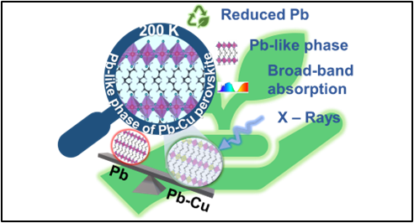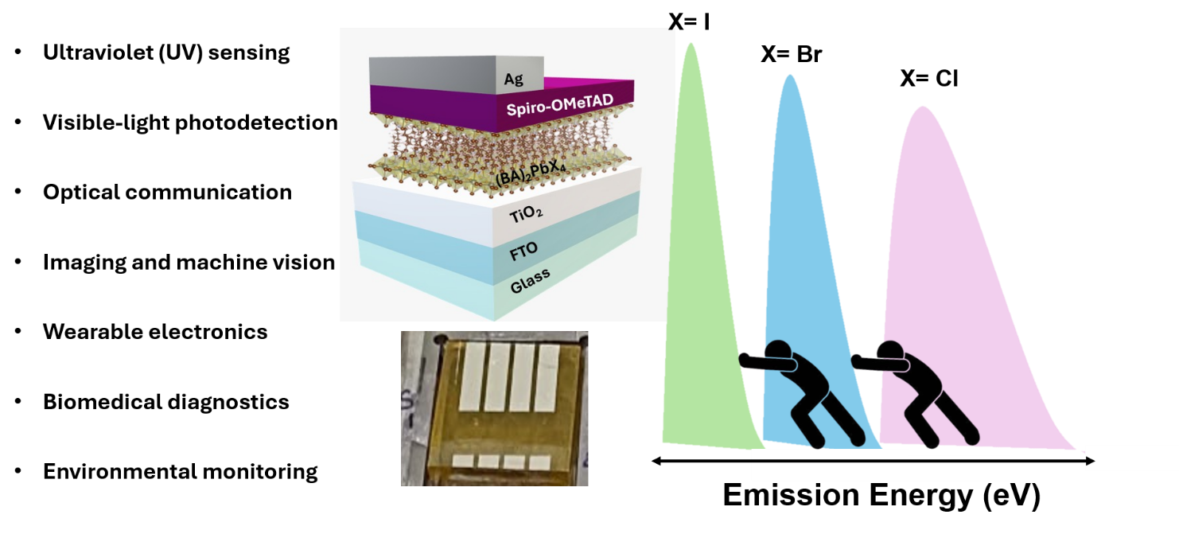

Halide Engineering in Low-Dimensional Perovskites (BA)₂PbX₄ (X = Cl, Br, I) for Optoelectronic Applications
Cu-Induced Phase Transitions and Energy Bandgap Tuning in 2D Ruddlesden-Popper Perovskites

List of Full time PhD scholars (as guide):
Ms. Shambhavi Jawahar Josi – Email ID: shambhavi1.mitblr2023@learner.manipal.edu
Ms. Shubha S Revankar - Email ID: shubha.mitblr2023@learner.manipal.edu
Mr. Daisy Maria Saju – Email ID: daisy.mitblr2023@learner.manipal.edu
Mr. Ganesh K Rahane – Email ID: ganesh.mitblr2023@learner.manipal.edu
Mr. Mohan Ram – Email ID: mohan.mitblr2024@learner.manipal.edu
Ms. Reshma Palled – Email ID: reshma.mitblr2024@learner.manipal.edu
List of Full time PhD scholars (as co-guide):
Mr. Robertson B – Email ID: robertson.mitblr2023@learner.manipal.edu
List of Part time PhD scholars (as guide):
NIL
List of Part time PhD scholars (as co-guide):
NIL

